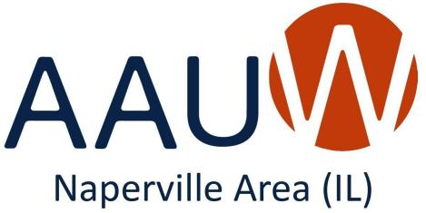
AAUW NAPERVILLE AREA (IL)
CRITERIA FOR THE
2024 ANGELINE GALE SCHOLARSHIP
(NOTE: In all cases where the terms "woman" or "women" are used
in this document, the intent is to include the category
"non-binary-presenting person.")

Age Requirement: Because the intention of this award is to help female or non-binary-presenting persons attain a college degree even when their education has been interrupted, the minimum age for applicants is 26.

Undergraduate Degree Program: Only students enrolled part-time or full-time in either an associate’s degree or bachelor’s degree program (including accelerated programs) at an accredited institution will be considered.

Graduation Timeline: Candidates must either: (a) be on track to earn 30 semester hours or its equivalent by July 1, 2024, if enrolled in an associate’s degree program, with the intent to continue and complete their associate’s degree OR (2) be on track to earn 60 semester hours or its equivalent by July 1, 2024, if enrolled
in a bachelor’s degree program, with the intent to continue and complete their bachelor’s degree.

Academic Scholarship: Because this is a scholarship and not a grant, the required cumulative GPA is 3.0. Official transcripts are required of all finalists.

Financial Considerations: The financial need of applicants will be considered. However, this does not necessarily mean that financial need will take precedence over scholarship. All criteria will be considered for each applicant.

Residency Considerations: The scholarship is available to those who reside in or attend school in DuPage, Will, Kendall, or Kane Counties in Illinois.

Quality of Written Personal Statement: We are looking for applicants who demonstrate excellent writing skills and can delineate clear academic and life goals. We are also looking for detailed explanations of financial need.

Quality of Interview: From the entire field of applicants, the most qualified candidates will be chosen to interview with the scholarship committee. We will be looking for articulate responses to our questions, especially regarding applicants' future plans and their opinions on the need for gender equality and higher education for women. We hope that the person chosen to receive the scholarship will consent to have AAUW Naperville Area follow up with her after the scholarship funds have been expended.

Future Goals: During the interview process, we would also like to hear how candidates imagine they will use their education to help create or enhance educational opportunities for women in their communities and in the broader society.

Submission of Application and Transcripts: The completed application, including the applicant’s personal statement and financial statements, must be submitted by regular mail to the address specified in the application. Applications must be POSTMARKED BY MARCH 15, 2024. If selected as a finalist, candidates must furnish official transcripts in the manner set forth in the application.

Publicity: The scholarship recipient must allow AAUW Naperville Area to use her name, likeness, and general information, such as school, field of study, and goals, for publicity purposes and must also attend the annual awards brunch on May 4, 2024.

